17th May 2016

**SEAT Leon Eurocup - Stian Paulsen wins in Silverstone**

The British home of motorsports, Silverstone witnessed thrilling racing with the second round of the SEAT Leon Eurocup International series which has YOKOHAMA as its exclusive tyre supplier.

Under glorious weather conditions race 1 took place on Saturday with Niels Langeveld (Baporo Motorsport) taking a deserved victory. He was followed by Spaniard Mikel Azcona (PCR Sport) and the current leader of the series from Norway, Stian Paulsen (Stian Paulsen Racing) in third.

On Sunday the first ten drivers on the grid set off from reversed positions, with an edge-of-the-seat, non-stop thrilling race. Stian Paulsen controlled the field right from the start to cross the chequered flag first and secure not only the top spot in the podium but additional points in his quest to keep the lead and conquer the Championship.

With his third and first place at the weekend he maintains himself as overall leader.

Although Paulsen was well over 4 seconds distant from second qualified Lourenço Beirao Da Veiga (PCR Sport), Beirao was kept very busy in an intense racing battle with home favourite, the Briton Alex Morgan (Wolf Racing) until the last corner although he eventually managed to secure the points and second place.

The versatile French lady, Lucile Cypriano (JSB Competition) also had a splendid weekend racing and impressed all claiming a very meritorious fourth place and now comfortably leads the ‘Ladies Trophy’ with 40 points.

After Silverstone, Stian Paulsen has consolidated his series lead with 84 points followed by Mikel Azcona with 70 and Niels Langeveld third with 53 points.

The next race will see competitors head off to the French circuit of Paul Ricard where the two races of the third meeting of the SEAT Leon Eurocup will take place on the 4th and 5th June.

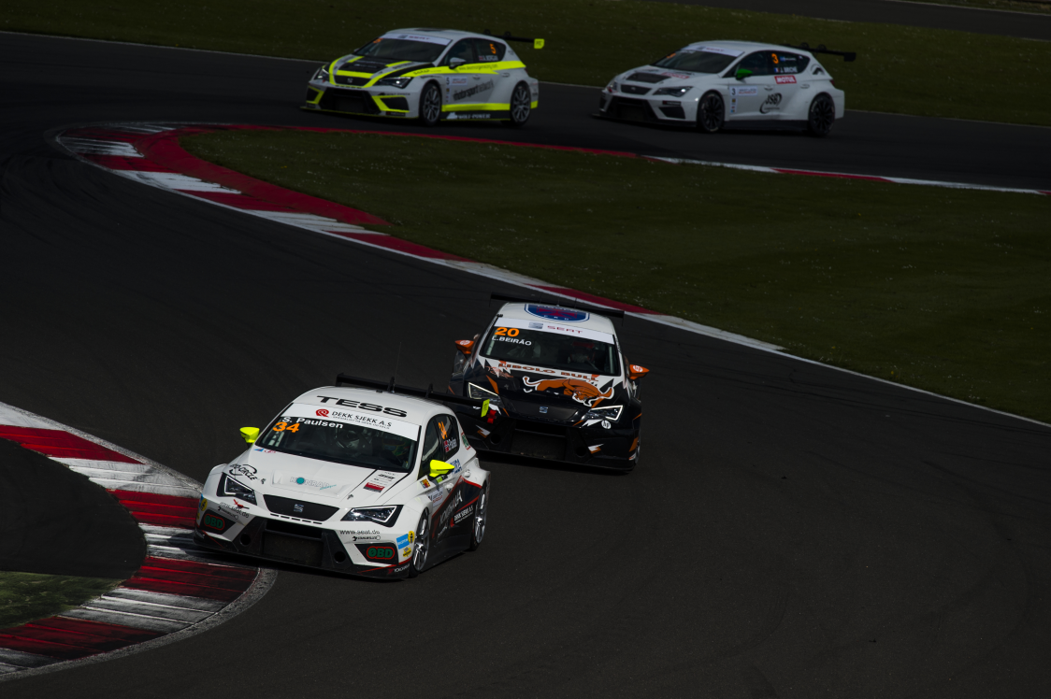

*Exciting battle in Race 2*

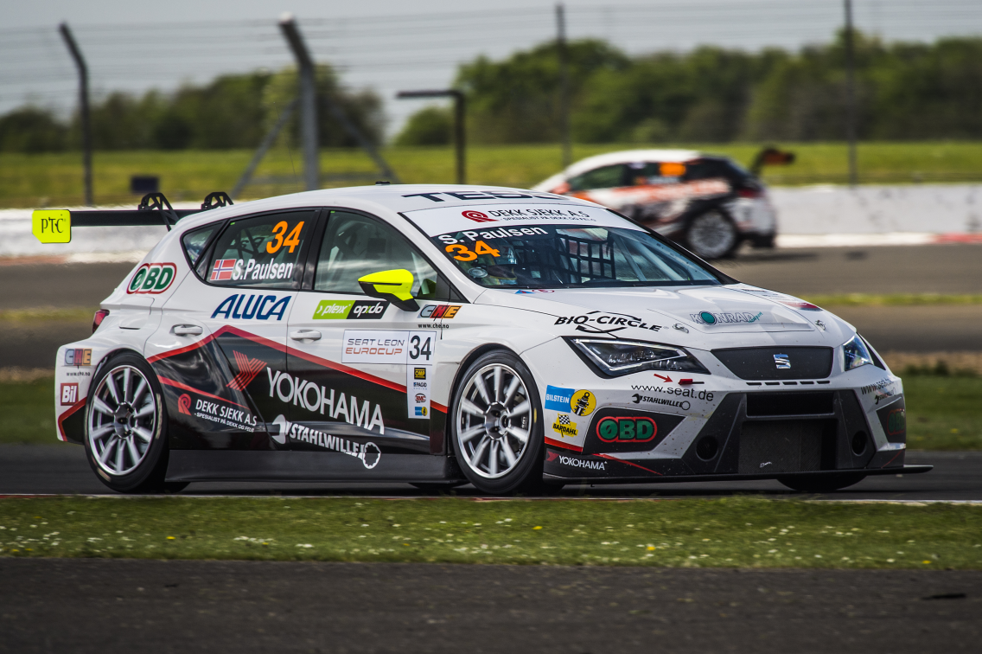

*Paulsen wins Race 2 at Silverstone*

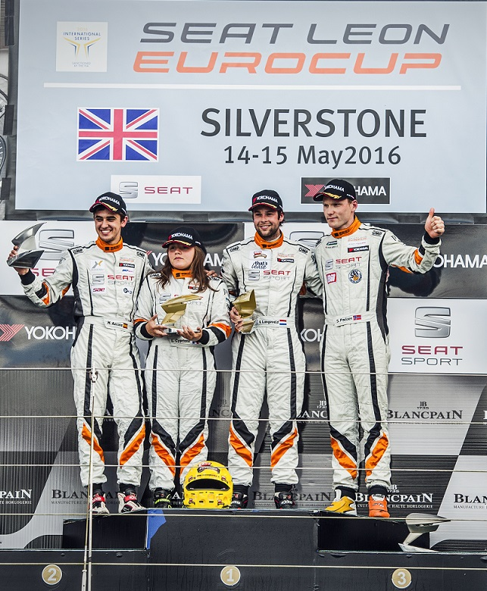

*Race 1 Podium*